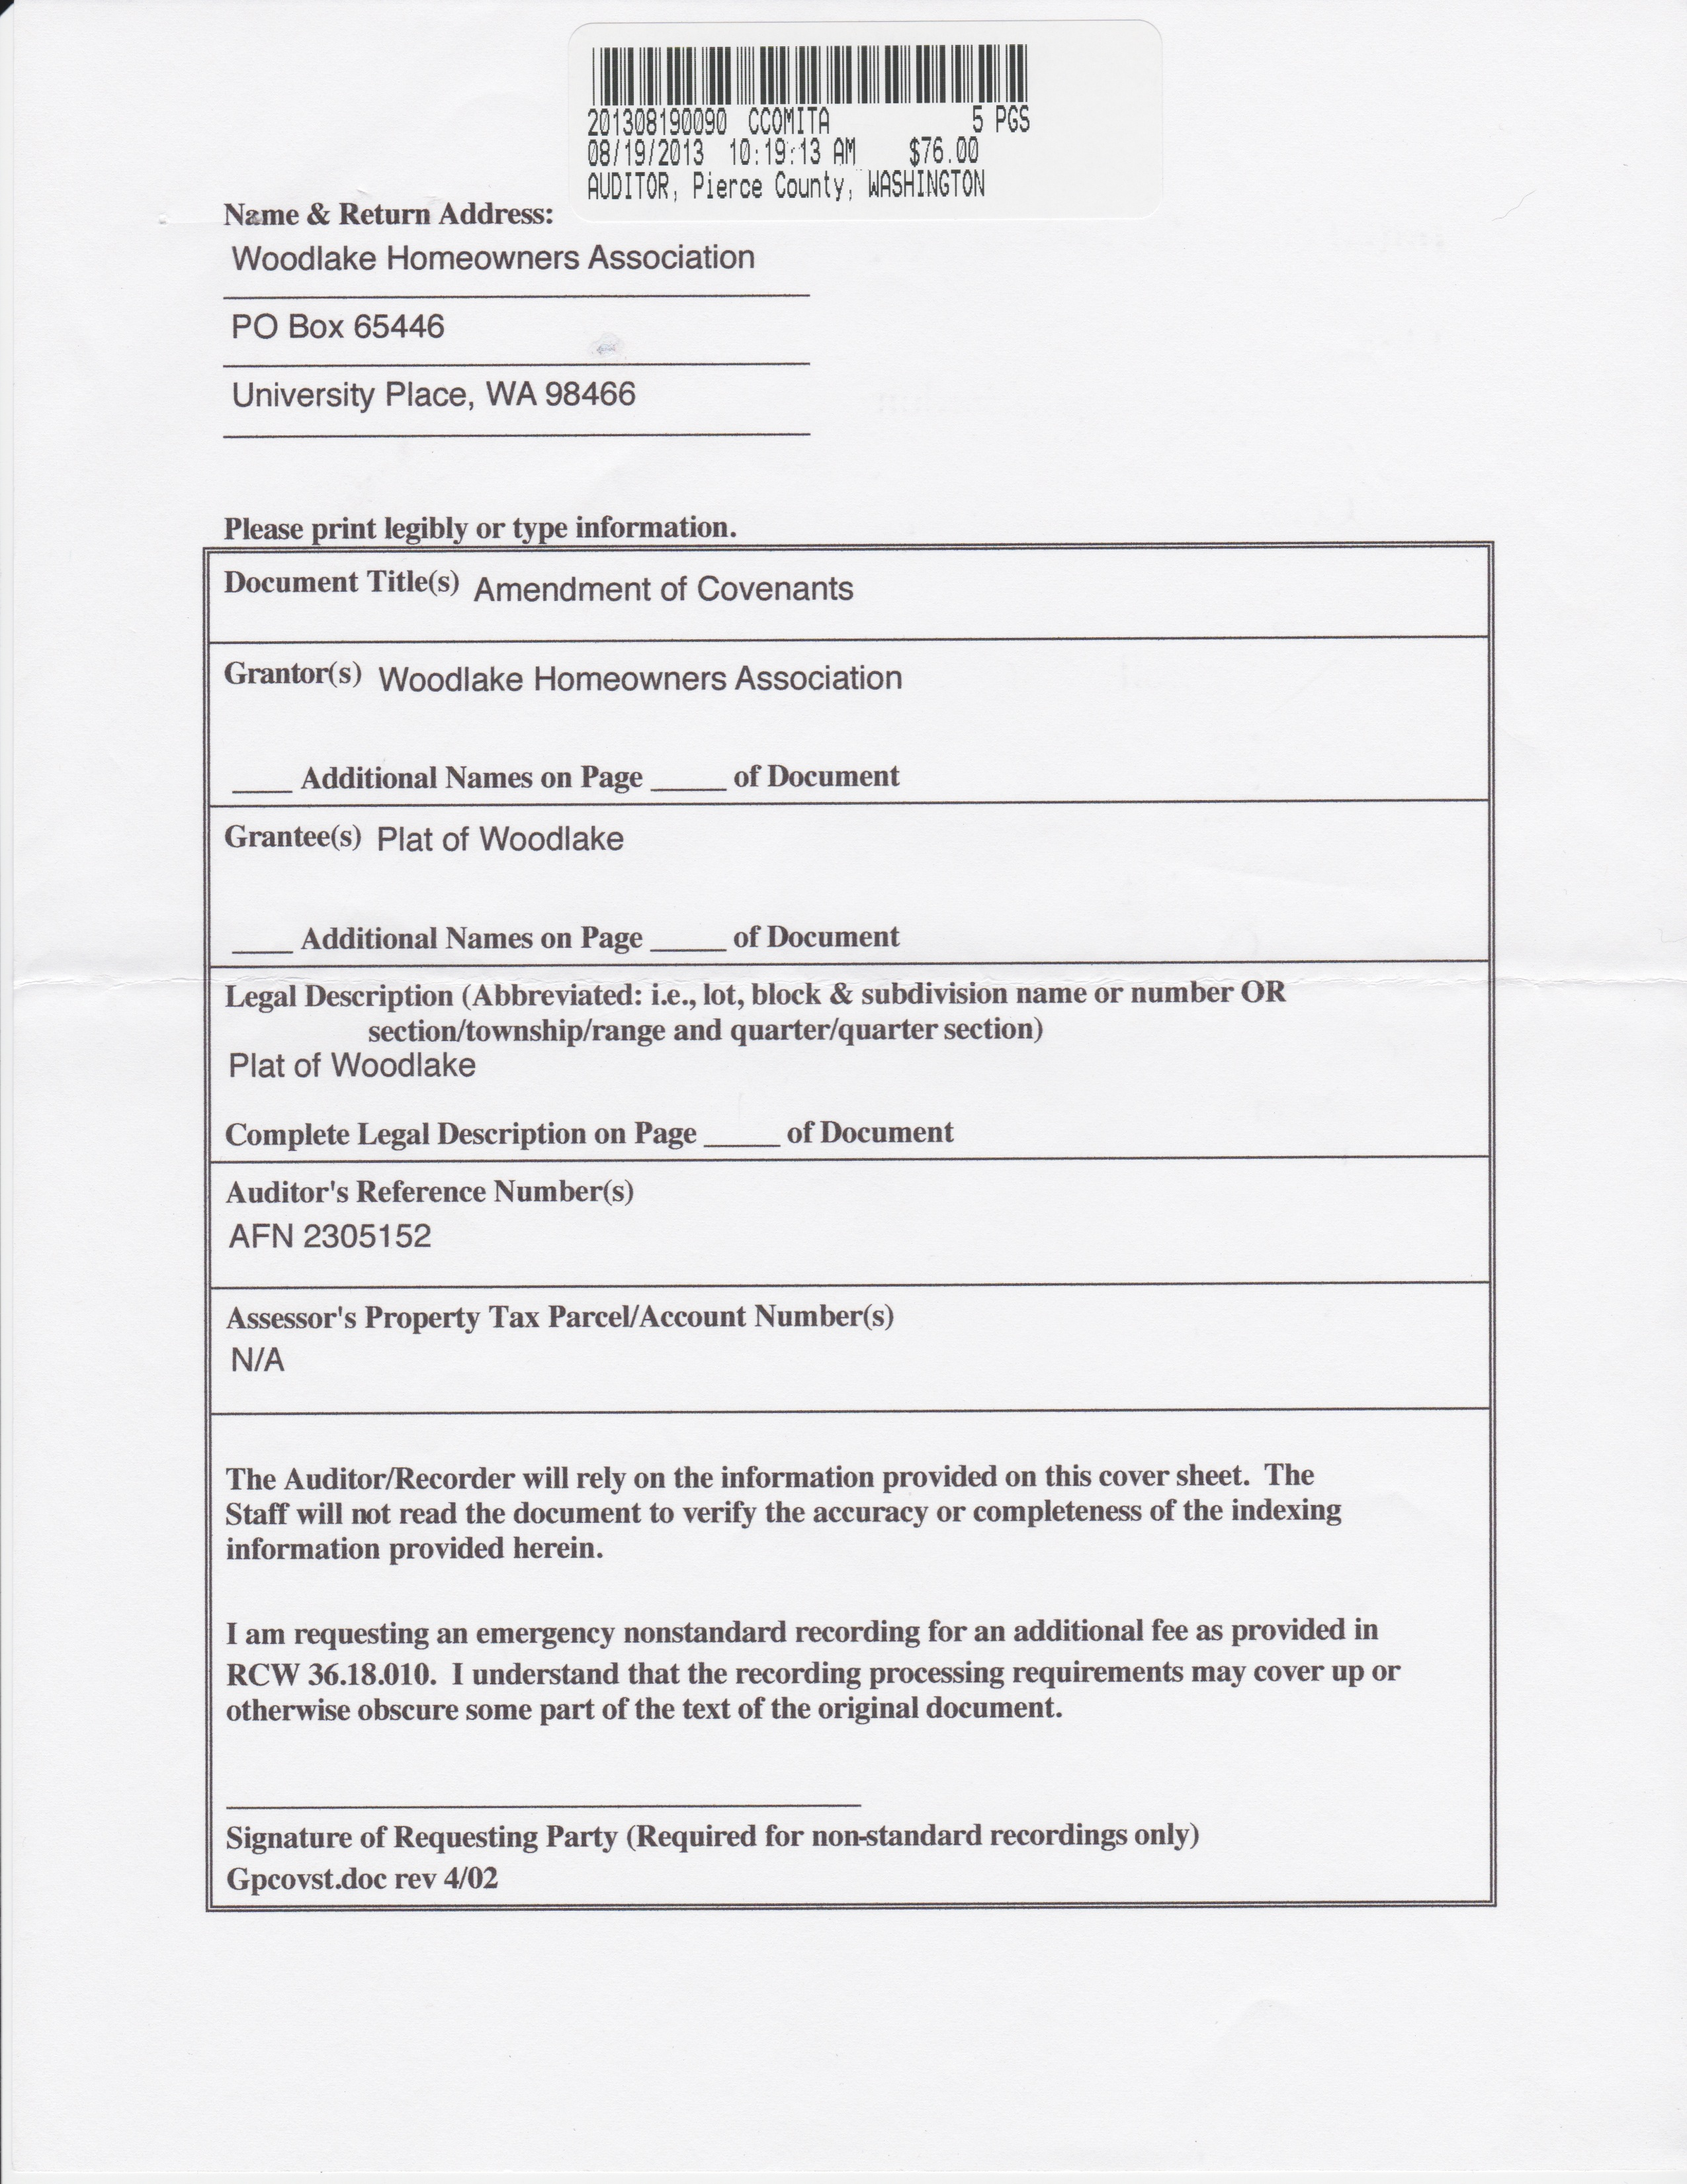

AMENDMENT OF COVENANTS
PLAT OF WOODLAKE

PLEASE TAKE NOTICE:

WHEREAS, The Declaration of Covenants, Conditions and Restrictions for the Plat of Woodlake, as recorded under Auditor’s No. 2305152, records of Pierce County, Washington, provides for amendment of the Declaration by approval or consent by a majority vote of Lot Owners voting on the matter referred by a plebiscite conducted by mail; and

WHEREAS, a majority of the Lot Owners voting on the matter referred have signed an instrument providing for the amendment of the Declaration as below stated; and

WHEREAS, The Board of Trustees of the Woodlake Homeowners Association, a Washington nonprofit corporation, desire to make the amendment a matter of public record;

NOW, THEREFORE, The Board of Trustees certify and declare that Article VI Section 8 of the Declaration is amended to include the following provision, which reads as follows:

Section 8. The Association may pursue any other legal remedies available in addition to foreclosing on the lien.

NOW, THEREFORE, The Board of Trustees certify and declare that Article VI shall include Section 11 of the Declaration, which reads as follows:

Section 11. Management and Enforcement: The following provisions will govern enforcement of the CC&R’s for all HOA members, their Renters and/or Lessees (Renters and or Lessees hereafter referred to as occupants). Association members or occupants in violation of the CC&R’s will be handled equally and without bias using the following process:

- Notification Process:
- The HOA Board of Directors (hereafter referred to as the Board) or their designated representative will provide the owner and/or occupant written notice detailing the violation with a request for correction of such violation. This written notice will serve as the first notification of violation.
- The property owner and or occupant will have seven (7) calendar days in which to correct and respond to the violation.
- If compliance or a plan of correction with a reasonable timeline is not forthcoming within seven (7) calendar days of the mailing of the first written notice, a registered second written notice will be sent. The content of this letter will notify the occupant and/or owner that the Board will impose a 30 day time period in which to correct the violation before a fine is imposed. The fine will begin on the 31st day following the mailing of the registered second letter and shall accrue for each day thereafter until the offense is cured. The fine shall be $20 per day. If the fine accumulates in excess of $500, the Board may impose a legal lien against such property at its discretion. If a lien is imposed, a third written notice will be sent notifying all parties of this action. The amount of the lien will increase for as long as the violation continues. The lien will be released upon full payment of the accrued fines.
- Should the fines accumulate in excess of $100, the Board may file judgment against the offending owner’s property. The amount of the judgment shall continue to increase for as long as the violation continues. The judgment will be released upon full remuneration of the accrued fines to the HOA. Notification of the judgments will be documented in a fourth written notice to the occupant and/or owner.
- The fine procedure listed above will not constitute a waiver of any of the other remedies available to the HOA Board as a result of the offending parties’ practices. Nor does it constitute the sole remedy for the owner. Violations must be corrected.
- Fines:
- Offenders shall be fined on a daily basis until the offending activity and or offense is cured to the satisfaction of the Board. The fine is $20 per day and may be adjusted by the Board at their discretion.
- Appeal:
- An offending party has the right to appeal to the HOA upon receipt of the notification of a violation and or before implementation of the fine by sending a written notice to:

Woodlake Homeowners Association
P.O. Box 65446
University Place, WA 98466

- This initial review will be scheduled with the Board and the offending party no later than the next monthly meeting of the Board to attempt to resolve the issue. This initial review is subject to the following:
- The offending party must either:
- Present mitigating evidence that the violation of the CC&R’s has not occurred, or
- Present evidence that the violation has been cured.
- When a review has been requested, the effective date of the fine will be suspended until the Board decision has been rendered.
- If the offending party is found to be in violation of the CC&R’s, the fine shall commence accruing on the date of the initial review or thirty-first day (31) following the mailing of the registered letter informing the owner of the violations and fine.
- If the offending party is found not to be in violation of the CC&R’s, the fine shall be withdrawn.
- If the violation has been cured, the fine shall total the accrued amount from the date of the request for appeal or the thirty-first day (31) following the mailing of the registered letter advising of the initiation of the fine, whichever comes first, until the date of the review.
- In all cases, the actions are solely at the discretion of the Board.

NOW, THEREFORE, The Board of Trustees certify and declare that Article VIII Section 2 shall include the following subsection, which reads as follows:
(g) Failure to notify the ACC of any reportable lot improvements will be brought to the attention of the Board. If the lot improvement is not approved by the ACC, the homeowner will be required to make the necessary changes implemented by the ACC after notification. Notification by the ACC will initiate the notification process of Article VI Section 11.

NOW, THEREFORE, The Board of Trustees certify and declare that Article X subsection (e) shall be stricken and replaced with the following amendment, which reads as follows:
(e) The following types of vehicles are prohibited on any property in Woodlake unless properly screened from view: unsightly, abandoned, or disabled vehicles; travel trailers; campers; motorhomes; boats; utility trailers; construction equipment; and any truck larger than a 1 ton pick-up. Exceptions to this regulation will be made for recreational vehicles that are loading or unloading 24 hours prior to departure or upon return. The board or their designee must approve extended stays beyond 24 hours. Vehicles of the type mentioned above or larger are prohibited from parking on the street including common areas.

NOW, THEREFORE, The Board of Trustees certify and declare that Article X shall include the following subsections, which read as follows:
(s) Roof – The roof of any permanent or semi-permanent structure shall be kept reasonably free of unsightly debris including but not limited to: moss, tree limbs, cones, needles and leaves.
(t) Landscaping and Front Yard – Landscaping includes trees, shrubs, lawns and rockery. All landscaping will be kept reasonably trimmed and neat. Lawns will be kept mowed. Weeds will be removed from the lawn and flowerbeds as needed.

